1. **W**e have another decorator which allows us to access host element’s properties (element on which decorative sits) to manipulate instead of using **Renderer2** in directive.  
   **NOTE**: To use Renderer2 ref to manipulate host element’s properties is not wrong but there is just another way we’re discussing.
2. **@HostBinding** imported from @angular/core.
3. 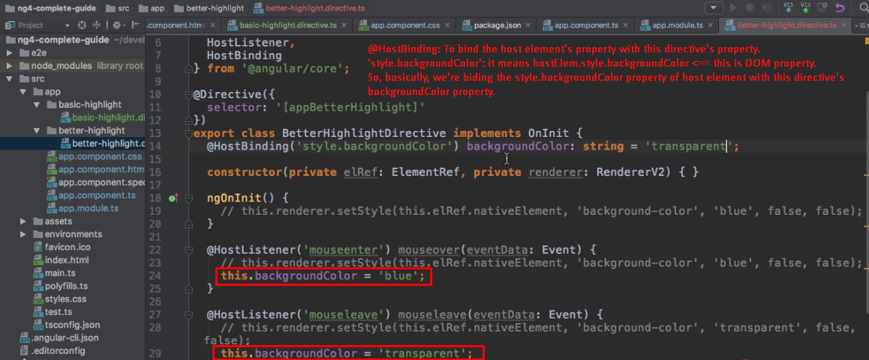
4. 